Project: Woodson Park Academy & YMCA-ELC
Week Ending: September 6th, 2019

THIS WEEK:
- Aggregate pier install
- Grading continued
- Storm line “A” install
- Finished French drain

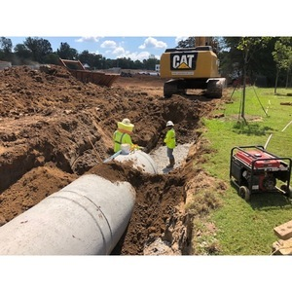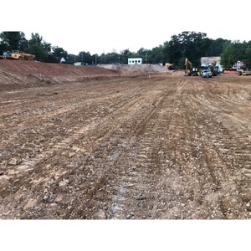

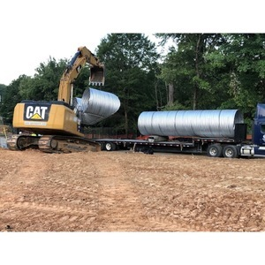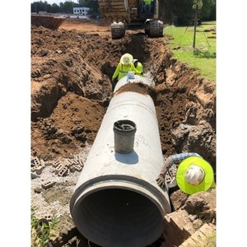

NEXT WEEK – September 9 thru September 13:
- Groundbreaking
- Aggregate pier to be completed on LL
- Storm line install continued
- Foundation wall rebar to be delivered

PAYMENT STATUS:
- Gmp#1 $3,703,488.00
  - Paid to date amount $646,892.85
- GMP#2 $28,686,295.00
  - Paid to date amount $0.00

SCHEDULED DATE OF SUBSTANTIAL COMPLETION
- WPA – September 28, 2020
- YMCA-ELC - September 16, 2020

PREPARED BY:
- Matt Dauber, Carroll Daniel Construction Co.

